Financial Economic Final Memo

By: Kaiyue Wang, Jack E Nation

Modern Portfolio Theory

The Modern Portfolio Theory is a theory that based on a given level of market risk the risk-averse investors focus on constructing portfolios to maximize the expected return and the Markowitz model is an important model for Modern Portfolio Theory. What’s more, investors should buy the stocks that are not positively correlated in order to avoid the huge damage. For a given level of expected return, MPT can also be used to construct a portfolio in order to minimize the risk and this can evaluate whether the investment affects the overall portfolio's risk and return. MPT helps investors to build diversified portfolios in order to let investors access different asset classes more easily and it can be used to reduce volatility. For instance, by using MPT if we put a small portion of portfolio in government bond ETFs which will help stock investors to reduce the risk.

The Markowitz model is a model that assists in selecting the most efficient portfolio if we analyze different portfolios for given securities, so this is also called a portfolio optimization model. In order to select the optimal portfolio, we need to analyze the preferences of the risk-return. For instance, the lower left frontier is always an investor holding a higher risk averse portfolio and the upper portion of the frontier is always chosen by a lower-risk averse investor. The main idea behind the modern portfolio theory is that it is possible to design an ideal portfolio that takes an optimal amount of risk which gives investors maximum returns. What’s more, MPT advocates investors to not invest in the same stocks which shows the importance of the diversification of securities and asset classes. MPT also tells investors that stocks face both systematic risk and unsystematic risk such as recessions, interest rates, and individual stocks.

Modern portfolio theory is the philosophical opposite of traditional stock picking. It is the creation of economists, who try to understand the market as a whole, rather than business analysts, who look for what makes each investment opportunity unique. Investments are described statistically, in terms of their expected long-term return rate and their expected short-term volatility. The volatility is equated with "risk", measuring how much worse than average an investment's bad years are likely to be. The goal is to identify your acceptable level of risk tolerance, and then to find a portfolio with the maximum expected return for that level of risk.

In our client’s case due to their risk aversion we would not be recommending individual stock picking therefore the modern portfolio theory is a good basis for investment strategy. A few things we must inform the client is around risk. All investments come with some level of risk, and as we develop a risk weighted portfolio the client must be informed that as volatility increases your risk of losing your principal investment grows. Therefore, in simplest terms all things being equal we would like to develop a portfolio that minimizes the volatility.

Mean return is also called expected return that estimates an investor’s expectations for the loss or gain from a portfolio of investments. We look at the mean return for bond VUSTX is 0.00003296 and stock SPY is 0.0002826 where stock is larger than bond so SPY is better. The standard deviation for bond VUSTX is 0.007219 and stock SPY is 0.01254. And the correlation between the stock and bond is -0.32. The graph of the correlation of bond and stock shows that they don’t have a strong correlation since according to the graph below, only in 2000 the correlation for these two is 0.3 and all other times the correlation for these two is negative.

As we look at the graph of the returns for stocks first, in Jan/02/ 2009 and 2020 has a sharp increase and sharp decrease for the stock SPY’s returns which means at these two-time period the stock’s returns is really unstable and we cannot predict when the price will keep increase or keep decrease so stock has a higher risk at this time period. However, in 1998, 1999, 2001, 2003, 2011, 2019, 2020 all had a large fluctuation which means that stock SPY will change due to the economic change so this stock is not performing well we may not buy this. As we look at the graph of the bond we find out that the returns fluctuate increase in 2009 and 2012. The large fluctuation rate only happens in 2020 and 2021 so these years this bond’s return changes frequently. By comparing the stock and bond, we find out that the bond is more stable since it does not fluctuate as stock. However, we still cannot predict whether it will perform better in the future or not but I think bond VUSTX is more stable and worth buying.

The optimal risky portfolio after plugging in all the coefficients in the Markowitz spreadsheet shows the risk and the standard deviation of combination is 0.00652 and bonds weighted 0.4602, stocks weighted 0.5398 and the expected returns is 0.00017. The expected return is really low which is not so good. The portfolio of these two combines shows the standard deviation is 0.00652 which is smaller than the VUSTX and SPY so the portfolio is better since it has less risk. The expected returns for the portfolio is 0.00017 which is smaller than SPY but higher than VUSTX so SPY is better. However, as we compare all the coefficients above we find that the portfolio is the best.

Returns for bond VUSTX and stock SPY.

Bonds Stocks

1997-01-03 0.001014713 0.014250032

1997-01-06 -0.002030458 -0.008777486

1997-01-07 -0.003053437 0.012101128

1997-01-08 -0.003062790 -0.008748233

1997-01-09 0.007131971 0.008333382

1997-01-10 -0.010204170 0.010730602

Index Bonds Stocks

Min. :1997-01-03 Min. :-7.370e-02 Min. :-0.1158865

1st Qu.:2003-02-11 1st Qu.:-3.934e-03 1st Qu.:-0.0049942

Median :2009-03-18 Median : 0.000e+00 Median : 0.0006367

Mean :2009-03-17 Mean : 3.296e-05 Mean : 0.0002826

3rd Qu.:2015-04-23 3rd Qu.: 4.254e-03 3rd Qu.: 0.0062146

Max. :2021-05-28 Max. : 6.316e-02 Max. : 0.1355773

Standard deviation:

sd(etf_returns$Bonds)

[1] 0.007219298

> sd(etf_returns$Stocks)

[1] 0.01253943

Correlation between bond and stock:

> round(res, 2)

Bonds Stocks

Bonds 1.00 -0.32

Stocks -0.32 1.00

Visualize the return of bond and stock:

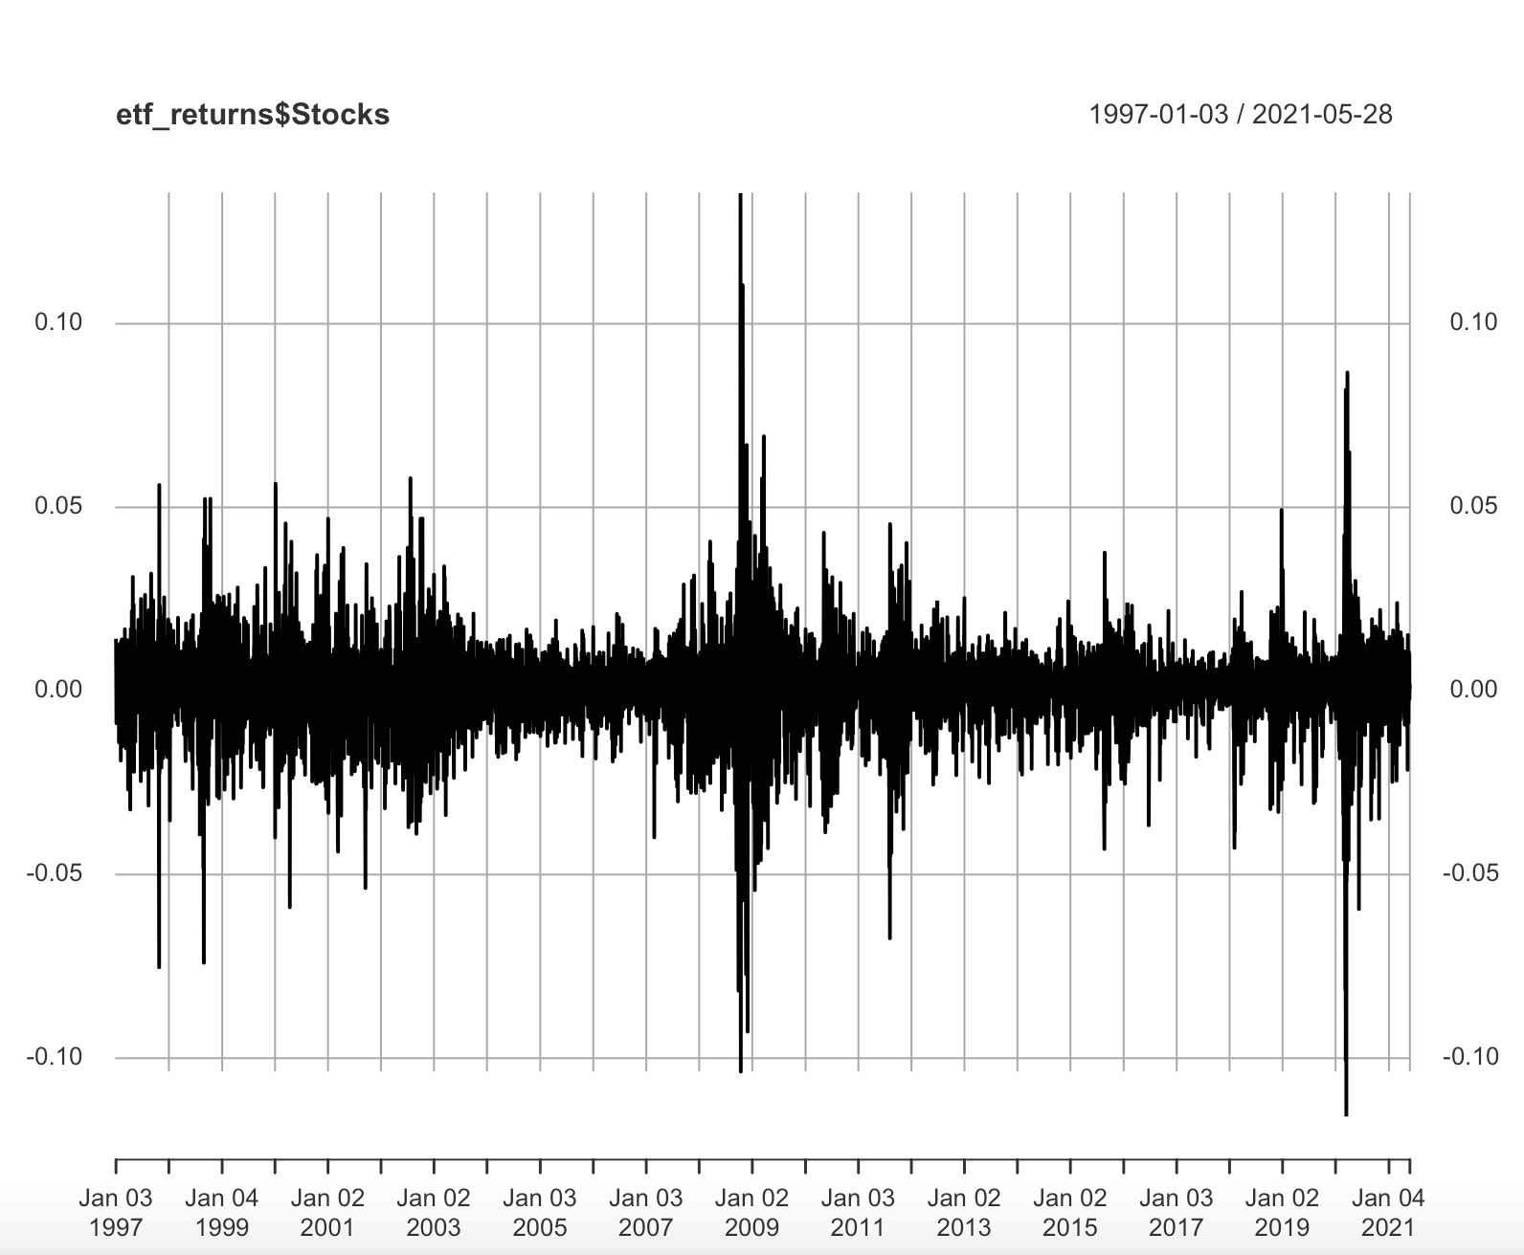

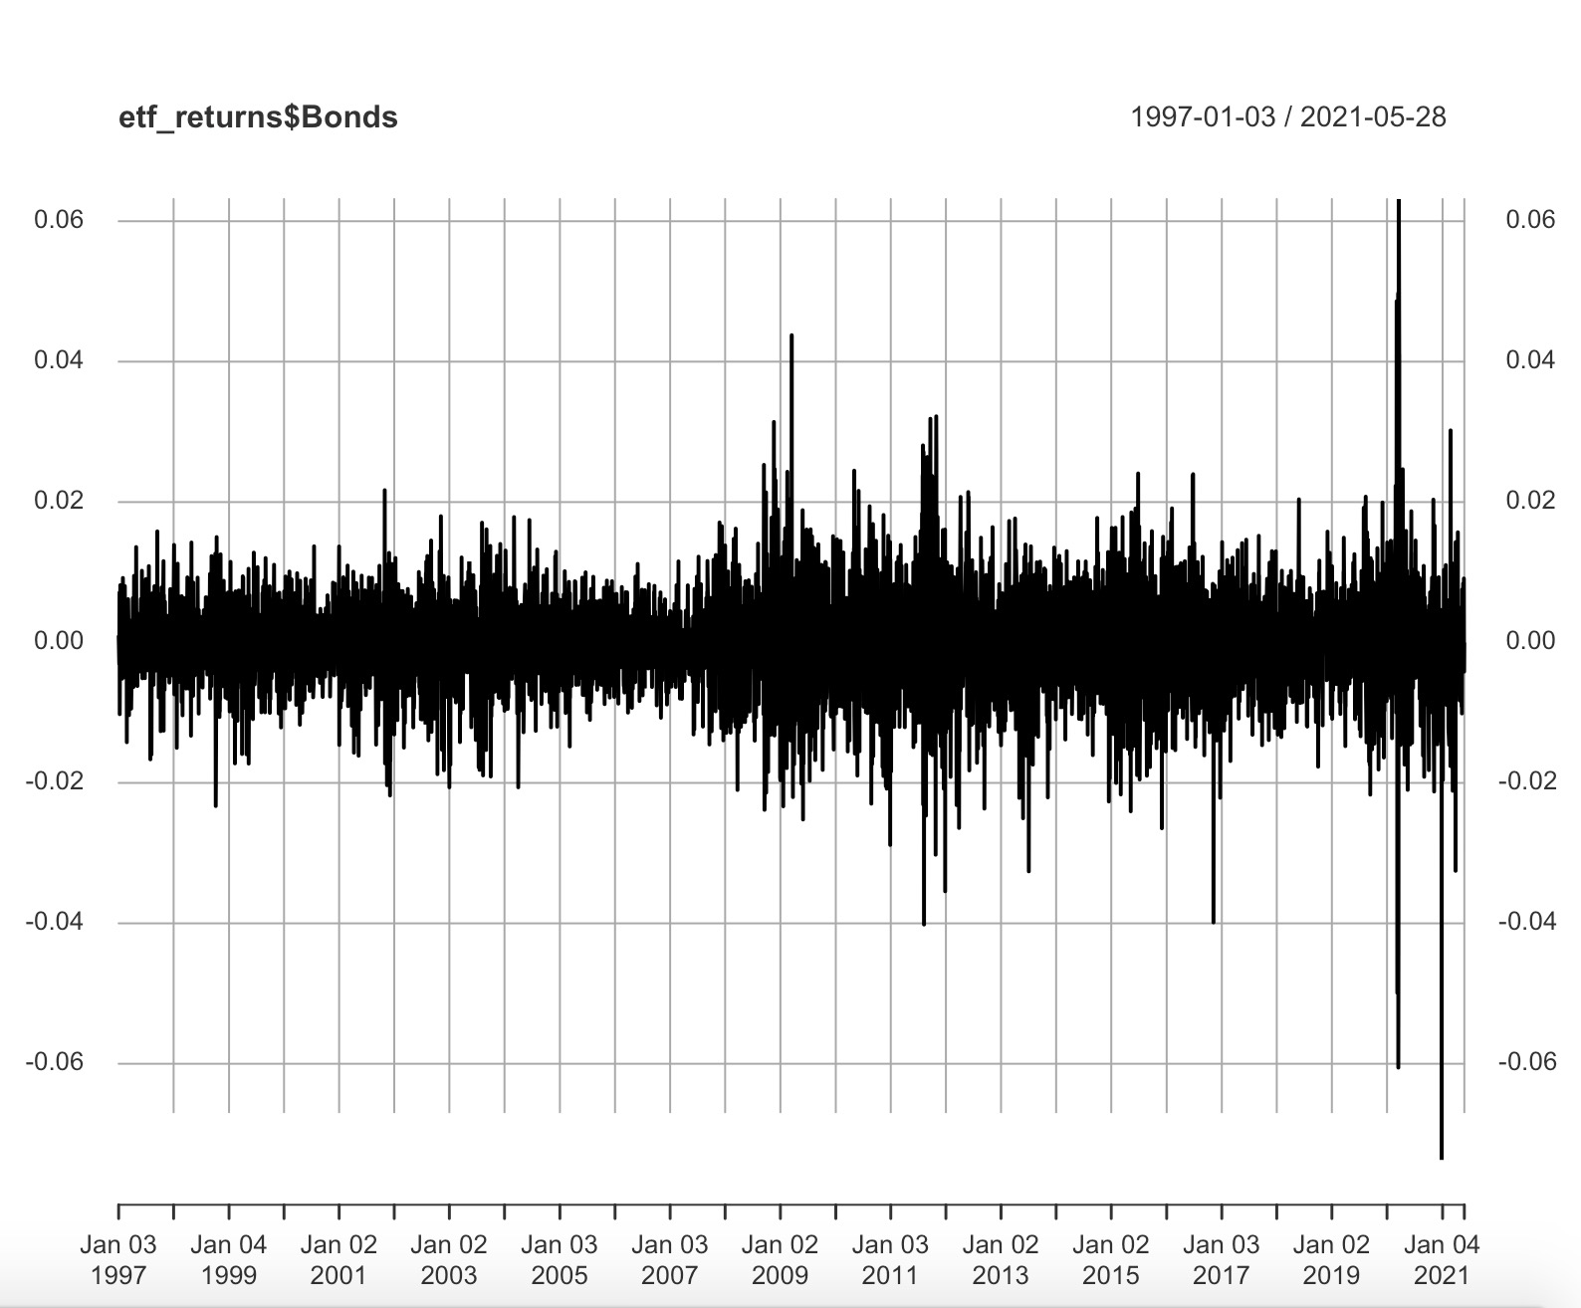

Correlation between bond and stock:

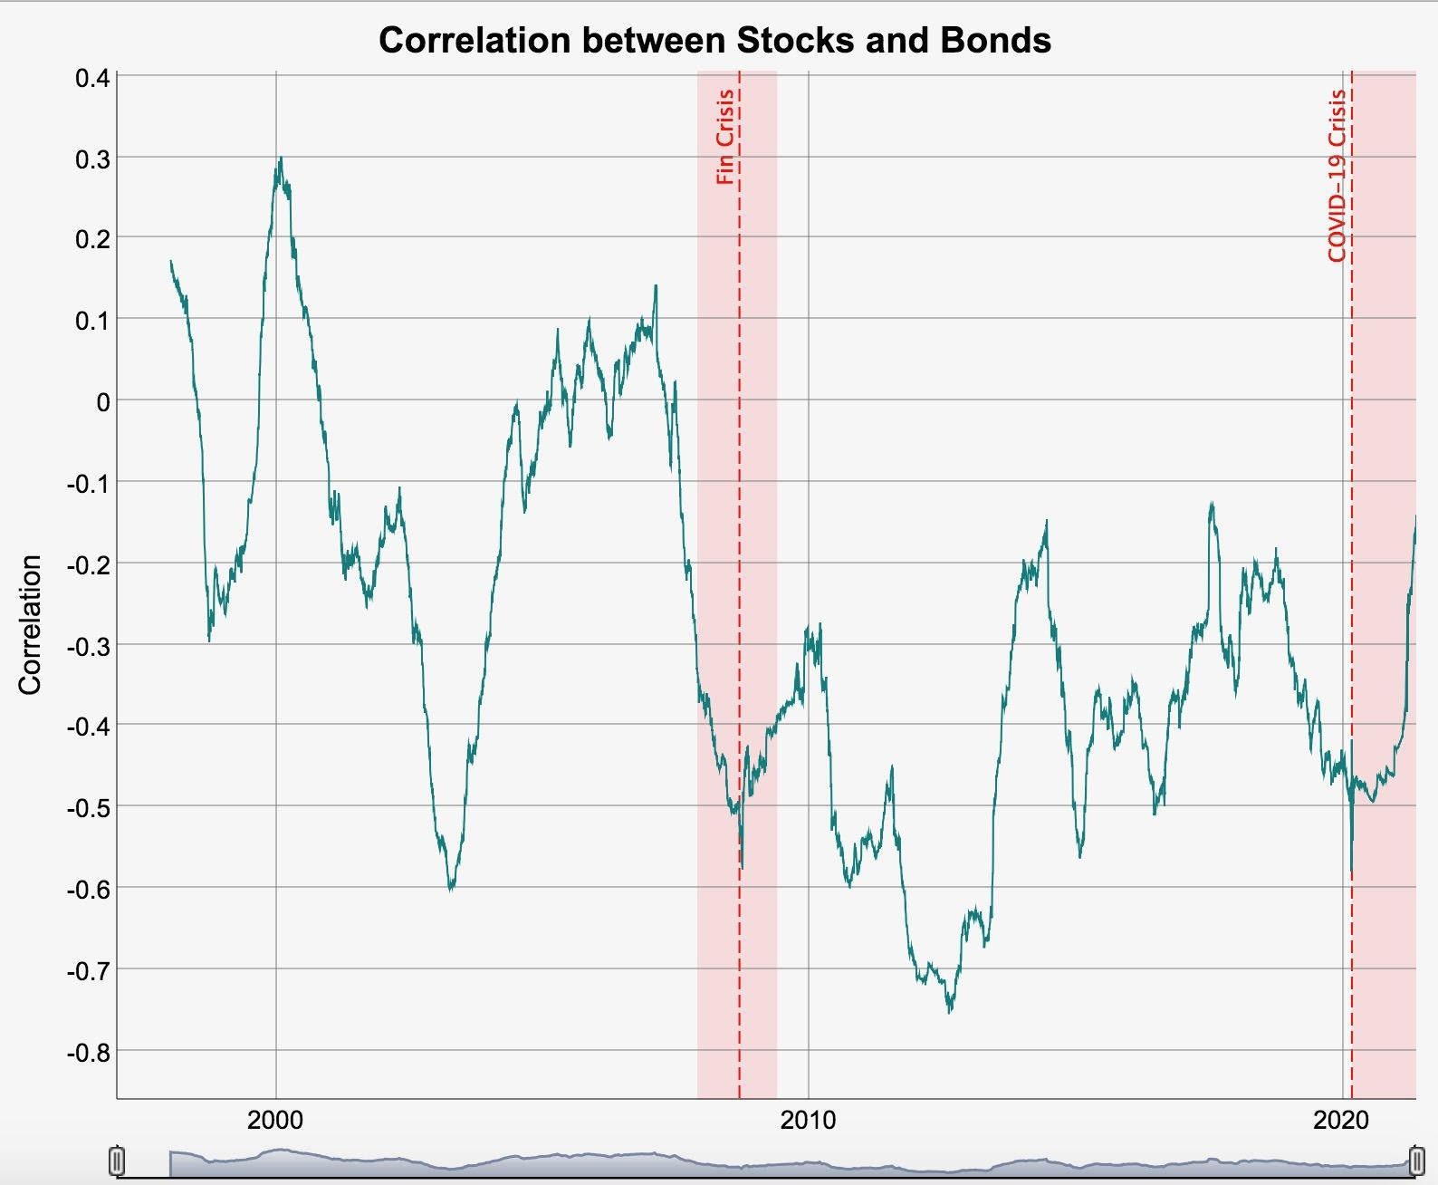

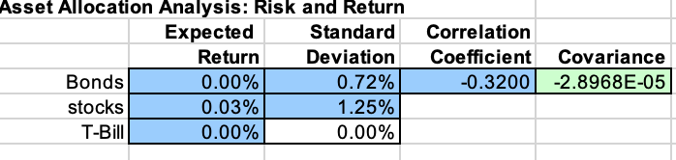

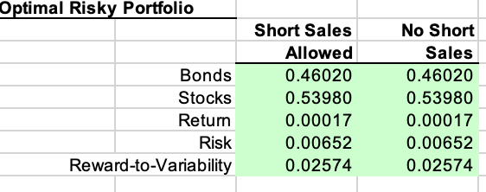

The analysis above was easy to use because it assumes that the investment universe consists only of two market securities simplified by using index funds that match the market in both bonds and stocks, plus riskless cash. But of course, the real investment universe is a lot bigger than that, with thousands of choices among U.S. stocks alone. In theory you could find the optimal point on the efficient frontier generated by this many security, but doing that wouldn't be practical. So as a practical matter, putting portfolio theory to work means reducing the problem to something about as simple as the portfolio demo, and investing in a small number of index funds rather than a huge number of individual stocks and bonds.

If you decrease the covariance between stocks and bonds, you can allocate more money to stocks and bonds and less to cash, thus raising your rate of return. (This is taking advantage of the curved shape of the Efficient Frontier, stretching it further to the left and tilting the lineup. By the way, the analysis above depicts a range of covariance, although negative covariance is possible, at least in theory. The size of the covariance will be on a scale roughly equal to the product of the two standard deviations; so for example, if the two investments have standard deviations of 15% and 7%, a large value for the covariance would be .15 x .07 = 0.0105.)

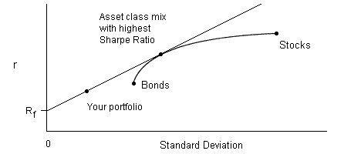

If you increase your risk tolerance to a high enough level, you'll get a zero-cash portfolio. This means you're up on the Efficient Frontier, but to the right of the point where it intersects the straight line. (In theory you could get up to the line even here if you are willing to hold a "negative" amount of cash, that is, to invest on margin.)

There are three recessions as we can see in the graphs below which give some suggestions to investors and the first recession happened in March and November 2001. During the first recession we can see the summary which shows the data about the mean expected return of the bonds is 0.0001164 and the stocks is -0.00188. The standard deviation for bonds is 0.01469756 and the stocks is 0.03467888. The correlation coefficient between stocks and bonds is -0.06 is negative which represents that the combination would reduce risk. As we look at the graph we find that the stocks and bonds have similar fluctuations. After we plug all the numbers into Markowitz spreadsheet, the optimal risky portfolio shows bonds weighted is -0.25774, and stocks weighted is 1.25774 and the expected return for risk is -0.239% and the standard deviation is 0.04401 which during the recession is strange. Because the expected return for stocks is negative and the expected return becomes negative then investors invest a negative proportion on bonds which means that during the recession investors invest more on stocks.

Head of 6 returns

Bonds Stocks

2001-03-09 0.004539272 -0.002024538

2001-03-16 0.009914457 -0.070087819

2001-03-23 -0.003593894 -0.004618937

2001-03-30 -0.018165804 0.019120702

2001-04-06 0.004572482 -0.029481668

2001-04-12 -0.020277192 0.047822982

summary

Index Bonds Stocks

Min. :2001-03-09 Min. :-0.0528757 Min. :-0.123341

1st Qu.:2001-05-14 1st Qu.:-0.0068152 1st Qu.:-0.018589

Median :2001-07-20 Median : 0.0045393 Median :-0.002025

Mean :2001-07-19 Mean : 0.0001164 Mean :-0.001880

3rd Qu.:2001-09-24 3rd Qu.: 0.0105680 3rd Qu.: 0.019189

Max. :2001-11-29 Max. : 0.0183974 Max. : 0.071019

Standard deviation of Bonds

0.01469756

Standard deviation of Stocks

0.03467888

Correlation between Bonds and Stocks

Bonds Stocks

Bonds 1.00 -0.06

Stocks -0.06 1.00

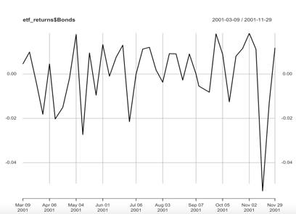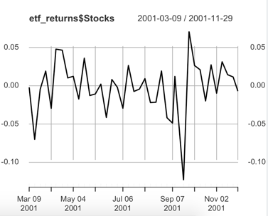

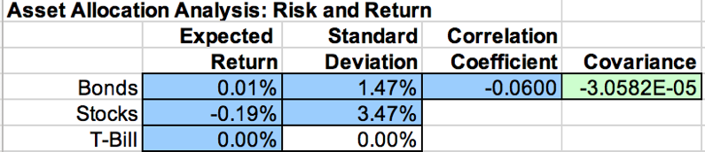

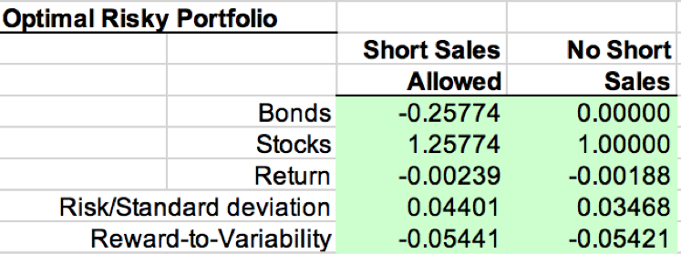

Second recession happened in December 2007 and March 2009. During this recession the summary of the data shows the mean expected return of the bonds is 0.0009465 and the stocks is -0.009419. The standard deviation for bonds is 0.01921289 and for stocks is 0.04951896. The correlation coefficient between stocks and bonds is -0.25 which is lower than the last combination which means that the combination will reduce more risks. As look at the graph below, stocks and bonds had a different fluctuation on October 3, 2008 and December 2008 to February 2009. Bonds had an even stronger fluctuation which represents that the expected return of bonds are more sensitive to economic changes. Then we plug in all the numbers into the Markowitz spreadsheet and we get the optimal risky portfolio that bonds weighted is -0.02542, and stocks weighted is 1.02542 and the expected return is -0.968% with risk and standard deviation is 0.0509. This is the same as the first recession where the investment proportion on bonds and expected return becomes negative which shows that during the recession when investing in an optimal portfolio, the investors were losing more benefits.

Head of 6 returns

Bonds Stocks

2007-12-14 -0.009687438 -0.025095292

2007-12-21 0.008810630 0.006501933

2007-12-28 0.002628122 -0.005618957

2008-01-04 0.019922703 -0.041515299

2008-01-11 0.000000000 -0.008242810

2008-01-18 0.011935351 -0.059456885

Summary

Index Bonds Stocks

Min. :2007-12-14 Min. :-0.0491710 Min. :-0.220564

1st Qu.:2008-04-11 1st Qu.:-0.0093578 1st Qu.:-0.034142

Median :2008-08-08 Median : 0.0008745 Median :-0.008243

Mean :2008-08-07 Mean : 0.0009465 Mean :-0.009419

3rd Qu.:2008-12-05 3rd Qu.: 0.0145738 3rd Qu.: 0.013333

Max. :2009-03-30 Max. : 0.0562578 Max. : 0.124801

Standard deviation of Bonds

[1] 0.01921289

Standard deviation of Stocks

[1] 0.04951896

Correlation between Bonds and Stocks

Bonds Stocks

Bonds 1.00 -0.25

Stocks -0.25 1.00

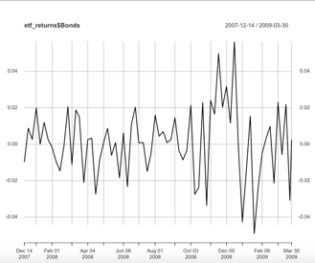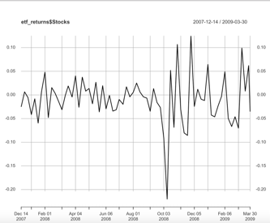

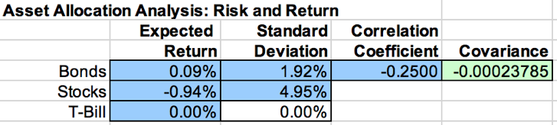

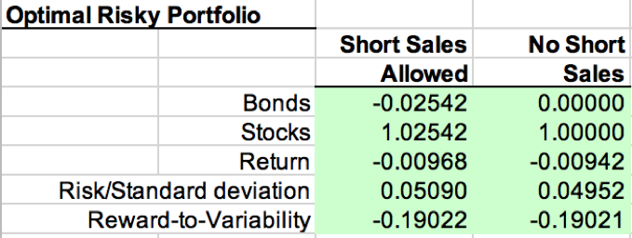

Third recession happened after February 2020 and the summary below of the data shows that the mean expected return of the bonds is -0.00212 and the stocks is 0.00345. The standard deviation for bonds is 0.02397651 and stocks is 0.04033555. The correlation coefficient between stocks and bonds is -0.11 which is still negative and the combination of these two will reduce risks as well. As we look at the graph we can see that bonds have an even stronger fluctuation which means that the expected return for bonds are more sensitive to economic changes. Then, after we plug in all the numbers into Markowitz spreadsheet we get the optimal risky portfolio that shows that the bonds weighted is 2.32728, and stocks weighted is -1.32728 and the expected return is -0.951% with risk and standard deviation is 0.08147. Different from the first two recession we can see that the investment proportion on bonds is higher than the first two, the stocks investment proportion is negative and as we compare the absolute value we find out that both of them exceed one and the expected return becomes negative. During the recession, investors are losing benefits if they invest in an optimal portfolio.

Head of bonds and stocks

Bonds Stocks

2020-02-14 0.000000000 0.016124547

2020-02-21 0.023413627 -0.012278854

2020-02-28 0.047252885 -0.118345446

2020-03-06 0.069126642 0.004042251

2020-03-13 -0.072476729 -0.099379442

2020-03-20 0.008686991 -0.163052017

Summary

Index Bonds Stocks

Min. :2020-02-14 Min. :-0.07248 Min. :-0.163052

1st Qu.:2020-06-10 1st Qu.:-0.01512 1st Qu.:-0.010618

Median :2020-10-05 Median : 0.00000 Median : 0.008196

Mean :2020-10-05 Mean :-0.00212 Mean : 0.003450

3rd Qu.:2021-01-30 3rd Qu.: 0.01001 3rd Qu.: 0.020266

Max. :2021-05-28 Max. : 0.06913 Max. : 0.114146

Standard deviation of Bonds

[1] 0.02397651

Standard deviation of Stocks

[1] 0.04033555

Correlation between bonds and stocks

Bonds Stocks

Bonds 1.00 -0.11

Stocks -0.11 1.00

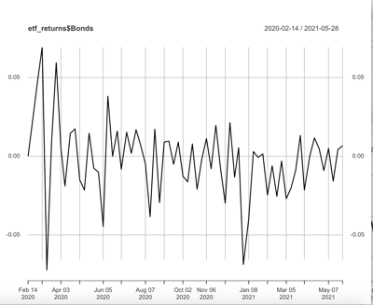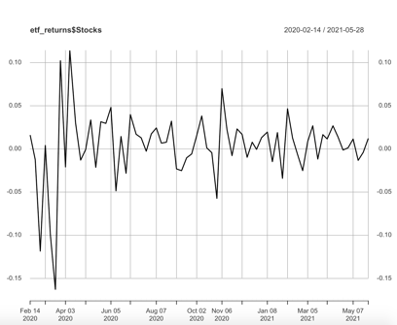

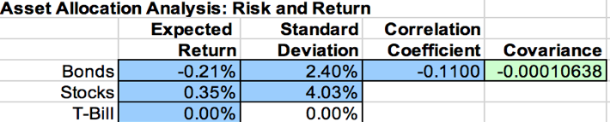

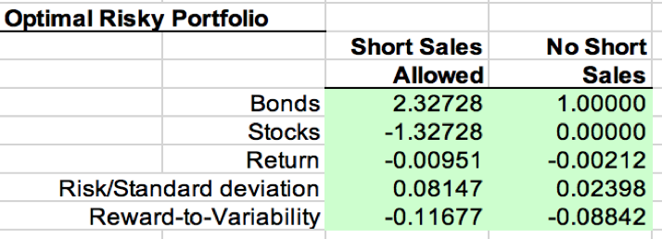

The whole period optimal risky portfolio has a different performance with other three recessions. As we compare these four, we can see clearly that only in the first recession it has a positive risk-reward ratio which is called Reward-to-Variability positive. Also, only the first recession has a positive return for asset aggregation, and all other three have a negative return which is armchairs. As we analyzed the recession above we realize that the bond and stock are available only in the second and third recessions. If in short sales, investors should buy the stocks because the bonds are shorted. If we were not in short sales, the investors should have completely invested in stocks. In the fourth recession, the situation will be the opposite direction since shorting is possible which means that the ideal portfolio is shorting stocks. Assets allocated bonds can’t be short in an asset portfolio. What’s more, if we look at the perspective of asset allocation ratio, we find that the bond and stock of the first recession are allocated at a ratio of about 50% each in the ideal portfolio.

Above are the analysis for different recessions and the portfolio of these two combines shows the standard deviation is 0.00652 which is smaller than the VUSTX and SPY so the portfolio is better since it has less risk. The expected returns for the portfolio are 0.00017 which is smaller than SPY but higher than VUSTX so SPY is better. However, as we compare all the coefficients above we find that the portfolio is the best. As we discussed above, in 02/Jan/ 2009 and 2020, the stock SPY’s returns which means the bond’s return is really unstable at these two periods. Also, in 1998, 1999, 2001, 2003, 2011, 2019, 2020 SPY has a large fluctuation but for bond VUSTX the large fluctuation rate only happens in 2020 and 2021 so bond is less risky.

And the correlation between the stock and bond is -0.32. The graph of the correlation of bond and stock shows that they don’t have a strong correlation since according to the graph below, in only 2000 year the correlation for these two is 0.3 and all other times the correlation for these two is negative which shows that the combination of stocks and bonds could help investor reduced risk since they were infected by economic factors in different levels. By comparing the stock and bond, we find out that the bond is more stable since it does not fluctuate as stock. What’s more, if you decrease the covariance between stocks and bonds, you can allocate more money to stocks and bonds and less to cash, thus raising your rate of return.

The CAPM and Multi-factor Models

The Capital Asset Pricing Model is a model that shows the relationship between expected return and systematic risk for assets, especially the stocks. CAPM examines the risk of assets and cost of capital for investors which are always used for pricing risky securities and generating the expected returns for assets. The equation of the CAPM is E(ri) = rf +bi(E(rm) – r), so according to this equation, investors should understand that in a potential investment the beta measures the risk of the investment that adds to a portfolio in order to make it look like the market. If a stock is riskier than the market, it will have a beta greater than one and if a stock has a beta of less than one, the formula assumes that it will reduce the risk of a portfolio.

The rival’s stock may have a higher beta than 1 so its stock is riskier than a market portfolio which means the real return may not be correct or the final result may can’t reach the 15% return since the risk is so high. Our company’s portfolio has a 10% rate of return which is more realistic. The portfolio with 15% expected will have a higher risk which is not a good product for you to invest. What’s more, the expected return of the CAPM calculates over the expected holding period the discount of expected dividends and capital appreciation of the stock. If the discounted value for future cash flows does not equals the money inventors invest which means that the CAPM formula represents the stock is not fairly valued relative to risk. The rival’s company just expects that the market will raise the value of the stock which has a higher risk so our company’s portfolio is better and more suitable for clients.

Alpha is the risk-adjusted measurement that is always used to measure the security performed in comparison to overall market average return which also shows in the profit or loss achieved relative to the benchmark. A basic calculation of alpha subtracts the total return of an investment from a comparable benchmark in its asset category. This alpha calculation is primarily only used against a comparable asset category benchmark. Alpha is also best used when comparing the performance of similar asset investments. So, at the onset, carrying your current portfolio mix to ours may not yield a apple to apples comparison. Our firm takes into consideration CAPM theory and risk adjusted measures by utilizing the risk-free rate and beta. We believe this strategy offers you greater stability in your current portfolio. In this case, the market expected return is 8%, risk-free rate was 0%. Our company’s expected return is 10%, Our company’s portfolio returns’ sensitivity to the market was 1, and my client’s consistently portfolio returns’ sensitivity to the market was 2. The rival company’s expected return is 15%. According to the equation of alpha, alpha = rp - [rf-β(rm-rf)]. For our company, alpha = 0.1 - [0+1(0.08-0) = 0.02 and other companies’ alpha = 0.15 - [0 + 2(0.08 -0)] = -0.01. By calculating the alpha, it shows that with less risk, our company is actually earning profits since the alpha value is 0.02 which is above the market return. However, their alpha is negative which means they are losing profits since their expected returns are below the market returns. Hence, our company performs better.

I don’t think my performance last year was pure luck since I already know the portfolio is always constructed in such a way and some of the firm has specific risk remaining in it which means that I have a lot of experience for my portfolio. Also, I always check the beta value and use the CAPM to examine the risk of assets and cost of capital for investors which are always used for pricing risky securities and generating the expected returns for assets. The equation for CAPM is E(ri) = rf +bi(E(rm) – r) and I always analysis the risk level according to this equation, investors should understand that in a potential investment the beta measures the risk of the investment that adds to a portfolio so I focus on the beta and usually check my portfolio’s beta number in order to check the risk level. Also, when beta is greater than 1 it's a cyclical stock and beta smaller than one it’s a defensive stock. I always pay attention to the economic change, when the economy is in recession and pandemic period, that means the price of defensive stock will be unaffected so I will recommend investors to invest in this kind of stock. When macroeconomic or systematic changes in the overall economy, the cyclical stock price will change so during the booming economy I will recommend my clients to buy the cyclical stocks. My performance last year was not only dependent on my luck but also on my own ability.

Defensive stocks typically have beta less than 1 and cyclical is greater than 1. As we look at the beta of CAPM below from Dec/01/2010, we find that Toyota is a defensive stock. Tesla and General Motors are cyclical stocks. For Fama-French three factor model, the answer doesn’t change.

CAPM:

|  |  |  |  |
| --- | --- | --- | --- |
|  | beta | Adjusted R-squared | Alpha |
| TSLA | 1.7177 | 0.1479 | 0.03256 |
| TM | 0.6197 | 0.2236 | -0.00006196 |
| GM | 1.462719 | 0.4279 | -0.008302 |

Fama-French:

|  |  |  |  |  |  |
| --- | --- | --- | --- | --- | --- |
|  | beta | SMB | HML | Adjusted R-squared | Alpha |
| TSLA | 1.75443 | 0.46329 | -0.94402 | 0.1568 | 0.02912 |
| TM | 0.6260765 | -0.1628926 | 0.1976895 | 0.2248 | 0.0004974 |
| GM | 1.202591 | 0.70536 | 0.760397 | 0.5148 | -0.002929 |

CAPM:

Tesla:

> summary(capm_TSLA)

Call:

lm(formula = TSLA ~ MKT_RF, data = ff_assets)

Residuals:

Min 1Q Median 3Q Max

-0.33263 -0.10045 -0.02825 0.07761 0.73005

Coefficients:

Estimate Std. Error t value Pr(>|t|)

(Intercept) 0.03256 0.01539 2.116 0.0364 *

MKT_RF 1.71770 0.36333 4.728 6.15e-06 ***

---

Signif. codes: 0 ‘***’ 0.001 ‘**’ 0.01 ‘*’ 0.05 ‘.’ 0.1 ‘ ’ 1

Residual standard error: 0.1643 on 122 degrees of freedom

Multiple R-squared: 0.1548, Adjusted R-squared: 0.1479

F-statistic: 22.35 on 1 and 122 DF, p-value: 6.151e-06

Toyota:

>summary(capm_TM)

Call:

lm(formula = TM ~ MKT_RF, data = ff_assets)

Residuals:

Min 1Q Median 3Q Max

-0.134730 -0.023065 -0.001194 0.023897 0.123543

Coefficients:

Estimate Std. Error t value Pr(>|t|)

(Intercept) -6.196e-05 4.349e-03 -0.014 0.989

MKT_RF 6.197e-01 1.027e-01 6.035 1.76e-08 ***

---

Signif. codes: 0 ‘***’ 0.001 ‘**’ 0.01 ‘*’ 0.05 ‘.’ 0.1 ‘ ’ 1

Residual standard error: 0.04644 on 122 degrees of freedom

Multiple R-squared: 0.2299, Adjusted R-squared: 0.2236

F-statistic: 36.42 on 1 and 122 DF, p-value: 1.762e-08

General Motors:

>summary(capm_GM)

Call:

lm(formula = GM ~ MKT_RF, data = ff_assets)

Residuals:

Min 1Q Median 3Q Max

-0.164005 -0.040055 -0.002861 0.036175 0.225840

Coefficients:

Estimate Std. Error t value Pr(>|t|)

(Intercept) -0.008302 0.006424 -1.292 0.199

MKT_RF 1.462719 0.151678 9.644 <2e-16 ***

---

Signif. codes: 0 ‘***’ 0.001 ‘**’ 0.01 ‘*’ 0.05 ‘.’ 0.1 ‘ ’ 1

Residual standard error: 0.0686 on 122 degrees of freedom

Multiple R-squared: 0.4326, Adjusted R-squared: 0.4279

F-statistic: 93 on 1 and 122 DF, p-value: < 2.2e-16

Fama-French Three factor model

Tesla:

> summary(ff3_TSLA)

Call:

lm(formula = TSLA ~ MKT_RF + SMB + HML, data = ff_assets)

Residuals:

Min 1Q Median 3Q Max

-0.32523 -0.10689 -0.01973 0.07132 0.74941

Coefficients:

Estimate Std. Error t value Pr(>|t|)

(Intercept) 0.02912 0.01558 1.870 0.0639 .

MKT_RF 1.75443 0.39164 4.480 1.72e-05 ***

SMB 0.46329 0.64895 0.714 0.4767

HML -0.94402 0.54208 -1.741 0.0842 .

---

Signif. codes: 0 ‘***’ 0.001 ‘**’ 0.01 ‘*’ 0.05 ‘.’ 0.1 ‘ ’ 1

Residual standard error: 0.1635 on 120 degrees of freedom

Multiple R-squared: 0.1774, Adjusted R-squared: 0.1568

F-statistic: 8.627 on 3 and 120 DF, p-value: 3.128e-05

Toyota:

>summary(ff3_TM)

Call:

lm(formula = TM ~ MKT_RF + SMB + HML, data = ff_assets)

Residuals:

Min 1Q Median 3Q Max

-0.13040 -0.02211 -0.00300 0.02213 0.13050

Coefficients:

Estimate Std. Error t value Pr(>|t|)

(Intercept) 0.0004974 0.0044219 0.112 0.911

MKT_RF 0.6260765 0.1111835 5.631 1.2e-07 ***

SMB -0.1628926 0.1842332 -0.884 0.378

HML 0.1976895 0.1538943 1.285 0.201

---

Signif. codes: 0 ‘***’ 0.001 ‘**’ 0.01 ‘*’ 0.05 ‘.’ 0.1 ‘ ’ 1

Residual standard error: 0.04641 on 120 degrees of freedom

Multiple R-squared: 0.2437, Adjusted R-squared: 0.2248

F-statistic: 12.89 on 3 and 120 DF, p-value: 2.342e-07

General Motors:

>summary(ff3_GM)

Call:

lm(formula = GM ~ MKT_RF + SMB + HML, data = ff_assets)

Residuals:

Min 1Q Median 3Q Max

-0.165475 -0.035432 -0.005826 0.033482 0.187519

Coefficients:

Estimate Std. Error t value Pr(>|t|)

(Intercept) -0.002929 0.006020 -0.487 0.627447

MKT_RF 1.202591 0.151369 7.945 1.18e-12 ***

SMB 0.705360 0.250822 2.812 0.005750 **

HML 0.760397 0.209518 3.629 0.000419 ***

---

Signif. codes: 0 ‘***’ 0.001 ‘**’ 0.01 ‘*’ 0.05 ‘.’ 0.1 ‘ ’ 1

Residual standard error: 0.06318 on 120 degrees of freedom

Multiple R-squared: 0.5266, Adjusted R-squared: 0.5148

F-statistic: 44.49 on 3 and 120 DF, p-value: < 2.2e-16

As we compare the SMB that uses 5% as a p-value cutoff. First, Tesla SMB is 0.46329 > 0.05 so this is a large capitalization stock. Toyota SMB is -0.6260765 < 0.05 so this is a small capitalization stock. General motor SMB is 1.202591 > 0.05 so this is a large capitalization stock. The results are consistent since Tesla and General Motor are older companies. General Motor was established in 1908 so this company should have a large capitalization stock so they will not be highly influenced by the pandemic or recession since they have stable customers and joint-ventures in different countries and they develop business in more than 140 countries. Tesla has higher market shares and develops really fast with new technologies so that’s the reason why it’s a large capitalization stock. However, Toyota is a company that is younger than General Motors and will be influenced by the economic recession and Toyota doesn’t have many new products and technologies that could attract the consumers so that’s also a reason why it’s a small capitalization stock.

As we compare the HML that uses 5% as a p-value cutoff. The coefficients of Toyota and General Motors’ HML coefficients are respectively 0.1976895 and 0.760397, both of them are greater than 0.05. Hence, Toyota and General Motors companies’ stocks’ book to market values are larger than 0.05 so they are all value stocks. However, Tesla has a negative HML coefficient that is -0.94402, with such a low B/M value represents that it is a growth stock. The results are consistent since as we compared the Tesla with Toyota and General Motors, it is a young company but a high technology company. Also, they try to design driverless cars which will be the most popular and new technology. General Motors and Toyota are established companies that always get returns from the existing assets so the results are consistent.

Alpha provides a measure of an investment’s performance relative to benchmark funds. Baseline on zero, a positive alpha implies that a fund generated returns better than its benchmark over a certain period, while a negative number of points to underperformance relative to the market. For example, an alpha value of one indicates that an investment’s return over a certain period was 1% higher than the benchmarks. When using CAPM the estimated alphas that were presented above, all 3 stocks appear to be negative, effectively stating that they did not outperform the market themselves. The p-value for each CAPM regression model is smaller than 0.05 so the CAPM model for each asset is significant. From the CAPM table we could see that the alpha for TSLA, TM, GM are respectively 0.03256, -0.00006196, and -0.008302 so no company has a better performance than a well-diversified portfolio. However, all three companies have alpha values smaller than 0.05 which means they are all losing profits, especially TM, and GM and their expected returns are all below the market returns. By looking at the Fama-French table, it has the same result that no company has a better performance than a well-diversified portfolio since all the alpha values are smaller than 0.05. Hence the result will not change. A beta reading of less than one suggests that a fund is less volatile than its benchmark. By utilizing beta we find that both Tesla and GM are more volatile than the market and Toyota is less volatile than the market. Then when we use the Fama-French modeling we find minimal change in alpha and beta for the given stocks. Although they are all slightly better with volatility following and alpha increasing we do not see any one stock outperform the broader market.

Utilizing R square, we find that General Motors has the highest correlation and is most predicted by our current model and Tesla has the lowest adjusted R square value which means it is predicted worst by Fama-French model. At .51 adjusted R square we find 51% of the behavior of General Motors is predicted, this is a stark contrast to the Tesla with an adjusted R squared of .16 or 16%. This is most likely due to the fact that Tesla is treated and valued more like a technology company rather than an automotive company. In general, all models can be further optimized, the question becomes a factor of overfitting. In this case adding an Arima function as well as bringing in volume as a condition may also play a factor in helping to determine how correlated the individual stocks are with the market. As the goal is to not overstate, we do not want to bring in too many conditions, yet only those that we believe will have additional value in the analysis. By focusing on volume we would be able to determine what percent of a daily shift is matched with the market. This would give us additional insight into if a client were to ask about a certain company what analysis we could offer them to guide them to the best investment strategy for their needs.

As the goal is to offer our clients the most potential upside while factoring in their unique risk tolerance level, we would want to set up a strategy that meets their needs but also makes them feel as if they are included in the logic process. By including one of the 3 stocks they have asked us to look into we can then present them with our findings that would summarize to a choice by them of a defensive stock such as Toyota, a more market consistent stock such as GM or a riskier stock that would depending on how much they wish to purchase would require rebalancing the remaining assets to ensure we were offering a consistent risk profile for their entire portfolio.

R Appendix:

Code for first part question 3:

library(tidyquant)

library(tidyverse)

library(dygraphs)

## preliminaries

ticker <- c("VUSTX", "SPY")

sector <- c("Bonds", "Stocks")

etf_ticker_sector <- data_frame(ticker, sector)

etf_ticker_sector <- tibble(ticker, sector)

## a function that we will use to get prices from Yahoo Finance and turn them into returns

etf_weekly_returns <- function(ticker) {

prices <-

getSymbols(ticker, src = 'yahoo',

from = "1997-01-01",

to = "2021-05-31",

auto.assign = TRUE, warnings = FALSE) %>%

map(~Cl(get(.))) %>%

reduce(merge) %>%

`colnames<-`(ticker)

prices_period <- to.period(prices, period = "week", OHLC = FALSE)

# get monthly log returns

returns <-na.omit(ROC(prices_period, 1, type = "continuous"))

# change date format

#index(returns) <- as.Date(as.yearmon(index(returns), format = '%Y%m'))

#Change the column names to the sector names from our data frame above.

colnames(returns) <- etf_ticker_sector$sector

returns}

## let's now use that function on our tickers

etf_returns <- etf_weekly_returns(etf_ticker_sector$ticker)

head(etf_returns)

## visualizing returns

plot(etf_returns$Stocks)

plot(etf_returns$Bonds)

summary(etf_returns)

sd(etf_returns$Bonds)

sd(etf_returns$Stocks)

etf_returns_nodate <- fortify.zoo(etf_returns)

etf_returns_nodate <- etf_returns_nodate[,c("Bonds", "Stocks")]

res <- cor(etf_returns_nodate)

round(res, 2)

plot(etf_returns_nodate$Bonds, etf_returns_nodate$Stocks)

abline(reg = lm( etf_returns_nodate$Stocks ~ etf_returns_nodate$Bonds), col = "red", lwd = 2)

Code for question 5

library(tidyquant)

library(tidyverse)

library(dygraphs)

#first recession

## preliminaries

ticker <- c("VUSTX", "SPY")

sector <- c("Bonds", "Stocks")

etf_ticker_sector <- data_frame(ticker, sector)

etf_ticker_sector <- tibble(ticker, sector)

## a function that we will use to get prices from Yahoo Finance and turn them into returns

etf_weekly_returns <- function(ticker) {

prices <-

getSymbols(ticker, src = 'yahoo',

from = "2001-03-01",

to = "2001-11-30",

auto.assign = TRUE, warnings = FALSE) %>%

map(~Cl(get(.))) %>%

reduce(merge) %>%

`colnames<-`(ticker)

prices_period <- to.period(prices, period = "week", OHLC = FALSE)

# get monthly log returns

returns <-na.omit(ROC(prices_period, 1, type = "continuous"))

# change date format

#index(returns) <- as.Date(as.yearmon(index(returns), format = '%Y%m'))

#Change the column names to the sector names from our data frame above.

colnames(returns) <- etf_ticker_sector$sector

returns}

## let's now use that function on our tickers

etf_returns <- etf_weekly_returns(etf_ticker_sector$ticker)

head(etf_returns)

## visualizing returns

plot(etf_returns$Stocks)

plot(etf_returns$Bonds)

#summary and standard deviation

summary(etf_returns)

sd(etf_returns$Bonds)

sd(etf_returns$Stocks)

## correlations across the whole sample

## eliminating time index from the FFp data

etf_returns_nodate <- fortify.zoo(etf_returns)

etf_returns_nodate <- etf_returns_nodate[,c("Bonds", "Stocks")]

res <- cor(etf_returns_nodate)

round(res, 2)

correlation <- function(returns, window) {

merged_xts <- merge(returns, etf_returns$Stocks)

merged_xts$rolling_test <- rollapply(merged_xts, window,

function(x) cor(x[,1], x[,2],

use = "pairwise.complete.obs"),

by.column = FALSE)

names(merged_xts) <- c("Sector Returns", "SPY Returns", "Sector/SPY Correlation")

merged_xts}

Bonds_Stocks_correlation <- correlation(etf_returns$Bonds, 260)

dygraph(Bonds_Stocks_correlation$'Sector/SPY Correlation', main = "Correlation between Stocks and Bonds") %>%

dyAxis("y", label = "Correlation") %>%

dyRangeSelector(height = 20) %>%

dyShading(from = "2020-03-13", to = "2021-05-31", color = "#FFE6E6") %>%

dyEvent(x = "2020-03-13", label = "COVID-19 Crisis", labelLoc = "top", color = "red") %>%

dyShading(from = "2007-12-01", to = "2009-06-01", color = "#FFE6E6") %>%

dyEvent(x = "2008-09-15", label = "Fin Crisis", labelLoc = "top", color = "red")

#Second recession

## a function that we will use to get prices from Yahoo Finance and turn them into returns

etf_weekly_returns <- function(ticker) {

prices <-

getSymbols(ticker, src = 'yahoo',

from = "2007-12-01",

to = "2009-03-31",

auto.assign = TRUE, warnings = FALSE) %>%

map(~Cl(get(.))) %>%

reduce(merge) %>%

`colnames<-`(ticker)

prices_period <- to.period(prices, period = "week", OHLC = FALSE)

# get monthly log returns

returns <-na.omit(ROC(prices_period, 1, type = "continuous"))

# change date format

#index(returns) <- as.Date(as.yearmon(index(returns), format = '%Y%m'))

#Change the column names to the sector names from our data frame above.

colnames(returns) <- etf_ticker_sector$sector

returns}

## let's now use that function on our tickers

etf_returns <- etf_weekly_returns(etf_ticker_sector$ticker)

head(etf_returns)

## visualizing returns

plot(etf_returns$Stocks)

plot(etf_returns$Bonds)

#summary and standard deviation

summary(etf_returns)

sd(etf_returns$Bonds)

sd(etf_returns$Stocks)

## correlations across the whole sample

## eliminating time index from the FFp data

etf_returns_nodate <- fortify.zoo(etf_returns)

etf_returns_nodate <- etf_returns_nodate[,c("Bonds", "Stocks")]

res <- cor(etf_returns_nodate)

round(res, 2)

#Third recession

## a function that we will use to get prices from Yahoo Finance and turn them into returns

etf_weekly_returns <- function(ticker) {

prices <-

getSymbols(ticker, src = 'yahoo',

from = "2020-02-01",

to = "2021-05-31",

auto.assign = TRUE, warnings = FALSE) %>%

map(~Cl(get(.))) %>%

reduce(merge) %>%

`colnames<-`(ticker)

prices_period <- to.period(prices, period = "week", OHLC = FALSE)

# get monthly log returns

returns <-na.omit(ROC(prices_period, 1, type = "continuous"))

# change date format

#index(returns) <- as.Date(as.yearmon(index(returns), format = '%Y%m'))

#Change the column names to the sector names from our data frame above.

colnames(returns) <- etf_ticker_sector$sector

returns}

## let's now use that function on our tickers

etf_returns <- etf_weekly_returns(etf_ticker_sector$ticker)

head(etf_returns)

## visualizing returns

plot(etf_returns$Stocks)

plot(etf_returns$Bonds)

#summary and standard deviation

summary(etf_returns)

sd(etf_returns$Bonds)

sd(etf_returns$Stocks)

## correlations across the whole sample

## eliminating time index from the FFp data

etf_returns_nodate <- fortify.zoo(etf_returns)

etf_returns_nodate <- etf_returns_nodate[,c("Bonds", "Stocks")]

res <- cor(etf_returns_nodate)

round(res, 2)

The code is (for question 4-8):

library(tidyverse)

library(lubridate)

library(xts)

library(zoo)

library(quantmod)

library(tidyr)

library(dplyr)

library(broom)

library(ggplot2)

library(tibbletime)

library(fpp2)

library(tidyquant)

library(dygraphs)

## loading the factors to R from the local drive; formatting the date; throwing out observation with missing date

FF <- read_csv("Downloads/F-F_Research_Data_Factors.CSV",

skip = 3) %>% rename(date = X1) %>% mutate(date = ymd(parse_date_time(date, "%Y%m"))) %>% na.omit(date)

## transforming FF into a long format for ggplot

FF_long <-

FF %>%

select(-RF) %>%

gather(factor, returns, -date)

## cumulative returns of the HML factor

FF_HML <- FF %>% select(date, HML) %>% mutate(HML = HML/100)

port_cumulative_ret <- FF_HML %>%

mutate(cr = cumprod(1 + HML))

port_cumulative_ret %>%

ggplot(aes(x = date, y = cr)) +

geom_line() +

labs(x = 'Date',

y = 'Cumulative Returns',

title = 'Portfolio Cumulative Returns') +

theme_classic() +

scale_y_continuous(breaks = seq(1,100,5)) +

scale_x_date(date_breaks = 'year',

date_labels = '%Y') + theme(axis.text.x = element_text(angle = 90))

#STOCKS

## pulling stock data straight from Yahoo Finance

symbols <- c("TSLA","TM","GM")

prices <-

getSymbols(symbols, src = 'yahoo',

from = "2010-12-01"，

auto.assign = TRUE,

warnings = FALSE) %>%

map(~Ad(get(.))) %>%

reduce(merge) %>%

`colnames<-`(symbols)

## converting the price date into monthly returns

returns <-

prices %>%

to.monthly(indexAt = "firstof", OHLC = FALSE) %>%

# convert the index to a date

data.frame(date = index(.)) %>%

# now remove the index because it got converted to row names

remove_rownames() %>%

# convert from wide to long creating new variable asset that will assign ticker, conversion needed to create returns using lagged variables

gather(asset,prices,-date) %>%

# compute returns using the usual way

group_by(asset) %>%

mutate(returns=(prices/lag(prices))-1) %>%

# remove prices

select(-prices) %>%

# convert back to wide by asset

spread(asset, returns) %>%

# remove missings

na.omit()

head(prices,10)

returns_df <- as.data.frame(returns)

head(returns_df,10)

#3 FACTOR MODELS

## merging asset returns with factors, and converting returns to excess returns

ff_assets <-

returns %>%

left_join(FF, by = "date") %>%

mutate(MKT_RF = `Mkt-RF`/100,

SMB = SMB/100,

HML = HML/100,

RF = RF/100,

TSLA = TSLA-RF,

TM = TM-RF,

GM = GM-RF) %>%

select(-RF,-`Mkt-RF`) %>%

na.omit()

#Tesla

## estimating CAPM model

capm_TSLA <- lm(TSLA ~ MKT_RF,data=ff_assets)

summary(capm_TSLA)

## estimating 3 factor model

ff3_TSLA <- lm(TSLA ~ MKT_RF + SMB + HML,data=ff_assets)

summary(ff3_TSLA)

#Toyota

## estimating CAPM model

capm_TM <- lm(TM ~ MKT_RF,data=ff_assets)

summary(capm_TM)

## estimating 3 factor model

ff3_TM <- lm(TM ~ MKT_RF + SMB + HML,data=ff_assets)

summary(ff3_TM)

#General Motors

## estimating CAPM model

capm_GM <- lm(GM ~ MKT_RF,data=ff_assets)

summary(capm_GM)

## estimating 3 factor model

ff3_GM <- lm(GM ~ MKT_RF + SMB + HML,data=ff_assets)

summary(ff3_GM)

Densities

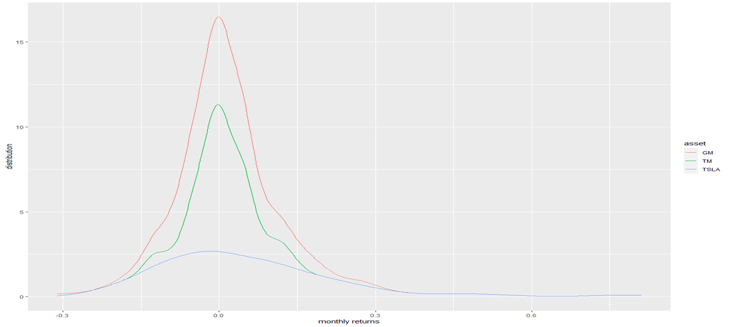

Histograms

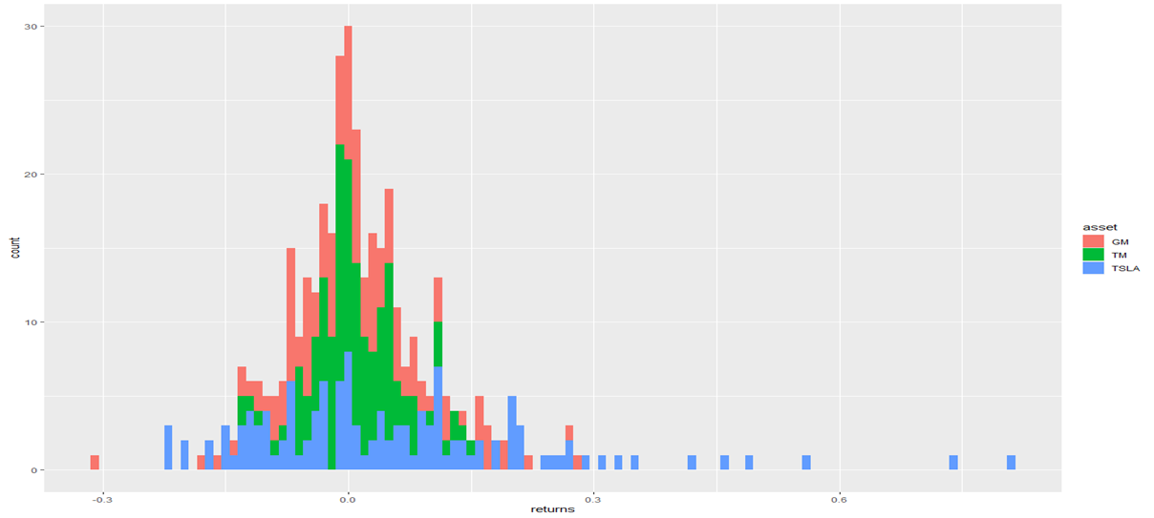

Returns over time

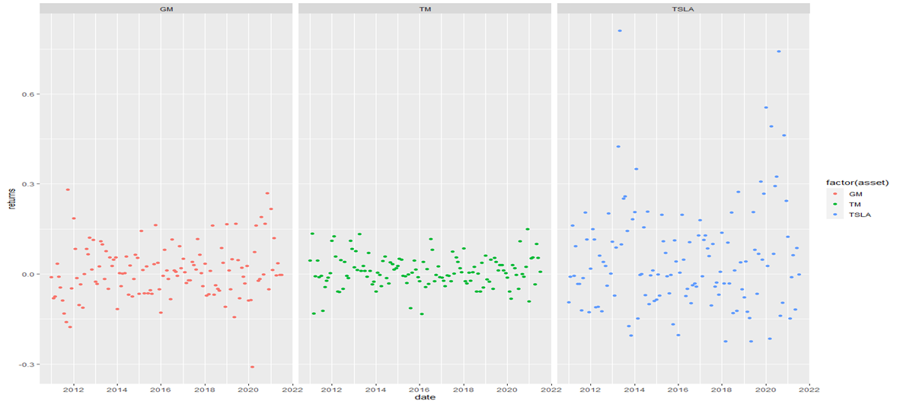

Comparison of percent gain over time

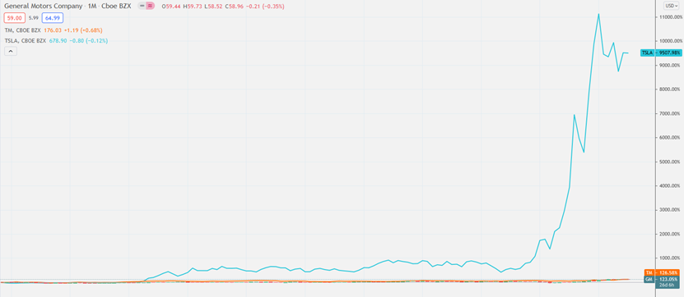

Depiction of volatility in stock price

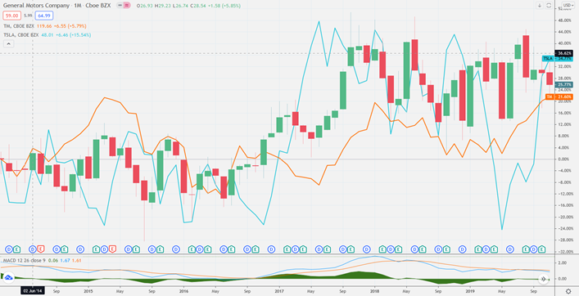

Depiction of Tesla breaking out away from the auto industry

